<!DOCTYPE html>
<html>
<head>
<title>For My Betuu 💖</title>
<style>
body {
font-family: 'Comic Sans MS', cursive;
background: #ffe6f0;
text-align: center;
color: #ff4d88;
padding: 20px;
}

.box {
background: white;
padding: 25px;
margin: 20px auto;
border-radius: 20px;
max-width: 400px;
box-shadow: 0 5px 15px rgba(0,0,0,0.1);
}

button {
background: #ff66a3;
color: white;
border: none;
padding: 10px 20px;
border-radius: 20px;
font-size: 16px;
cursor: pointer;
}

.heart {
font-size: 30px;
animation: beat 1s infinite;
}

@keyframes beat {
0% { transform: scale(1); }
50% { transform: scale(1.2); }
100% { transform: scale(1); }
}

img {
width: 200px;
border-radius: 15px;
margin-top: 10px;
}
</style>
</head>

<body>

<div class="box">
<h1>Hey Betuu 💕</h1>
<p>I made something special for my Bachhu… 🥺</p>
<button onclick="showLove()">Tap Me 😘</button>
</div>

<div id="love" class="box" style="display:none;">

<div class="heart">💖</div>

<h2>Happy Anniversary Bachhu 💕</h2>

<img src="
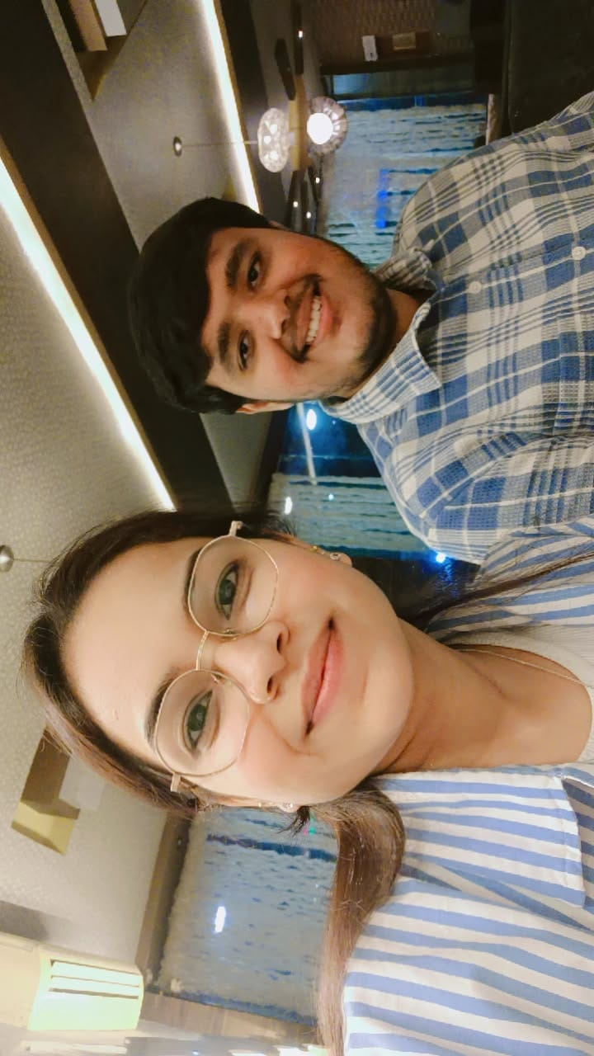
" alt="Our Cute Memory">

<p>
My Betuu 💖<br><br>
You are my favorite notification 📱💗

My daily smile 😊
And my happiest place 🥰
</p>

<p>
I love you more than everything… even more than pizza 🍕 😌
</p>

<h3>Forever yours ❤️</h3>
</div>

<script>
function showLove() {
document.getElementById("love").style.display = "block";
}
</script>

</body>

</html>

